Ideation Phase
Empathize & Discover

Date | 6 April 2026
Team ID | SWTID-2026-9601
Project Name | Smart library request workflow
Maximum Marks | 4 Marks

Empathy Map:
In the Smart Library Request Workflow, users often hear complaints about delays and lack of updates, while experiencing a manual process with no proper tracking. They feel frustrated and expect a faster, more efficient system. Users frequently ask for updates and repeatedly check request status, highlighting pain points such as slow processing and poor visibility. A smart solution can provide quick requests and real-time tracking, leading to a better user experience.

Example:
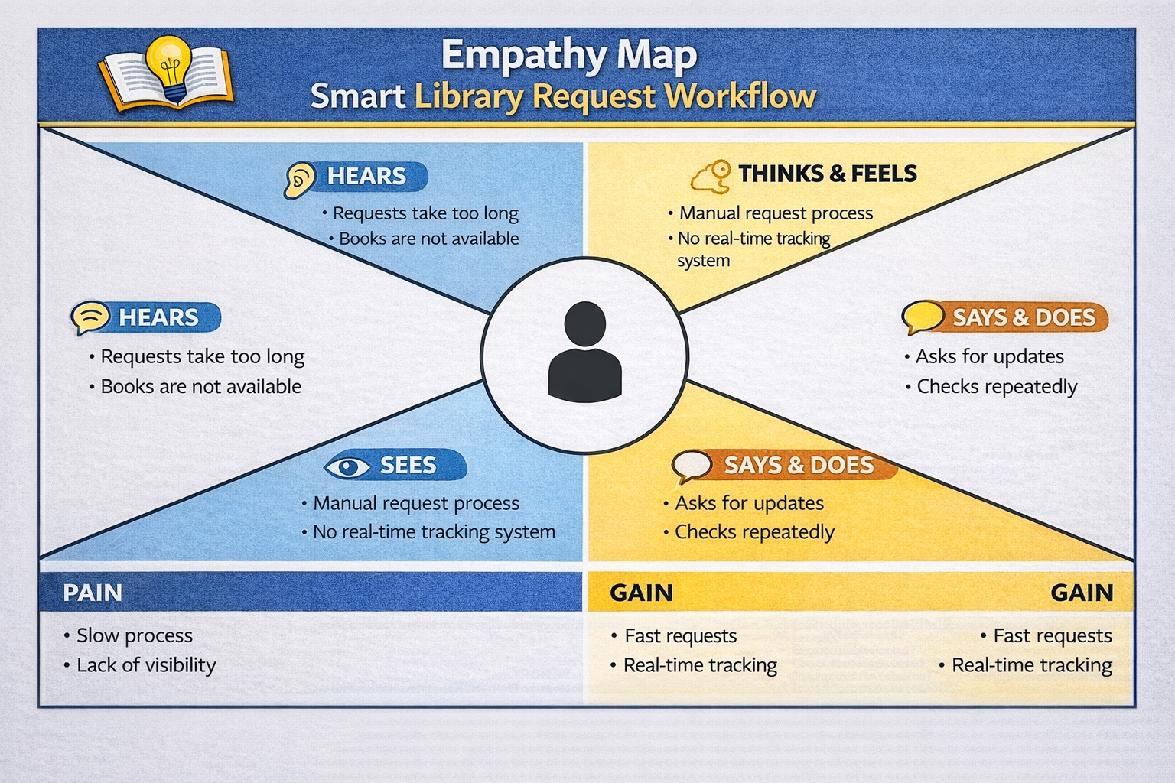

Example: Food Ordering & Delivery Application:
